This n That

An e-mail newsletter from Agapé Athletics Club

Editor: Marieta Bortoli 082 466 7031 25 March 2019 www.agape.org.za

E-mail: marietabortoli@gmail.com

NB

- Next league race – 30 March
- Awards function 4 May
- Agapé race (Jacaranda City Challenge) – 12 October. Members to assist. PLEASE DIARIZE !!!!!!

Editorial

This coming Saturday is a league race. Please come and run/walk as we need all possible points we can earn.

Remember to complete the entry form in full; i.e. name, surname, age, gender, club and Province (AGN).

Attached is an invitation to our awards function. Please confirm your attendance to Marix. This invitation is open to all our members who wish to attend whether you are the recipient of an award or not.

Notice Board Additions

◊ Ford 3-in-1
◊ JointEze Irene Ultra
◊ Frenus Zietsman Run/Walk against drugs
◊ Castle Walk Easter Road Race
◊ Run-a-Way Sport Family Day run/walk

Attachments

□ Awards function invite

Birthday Greetings

May your birthday bring joy, contentment and may the Lord’s blessing surround you.

Mag jy in hierdie nuwe lewensjaar ‘n innerlike vrede ken wat jou in staat sal stel om die eise en behoeftes van elke dag in die seker wete van die Heer se teenwoordigheid tegemoet te gaan.

William Kiewitt 01 April | Sonet Marais-Werner 02 April
Chris Mellamphy 03 April | Ian Mnisi 07 April
Corne Vermaak 07 April | Beverley Boyes 09 April
Bokang Kgasi 12 April | Seitricha Morrison 14 April
Magda Dippenaar 17 April | Mamiki Maselkgoma 19 April
Marike Boudouris 21 April | Erika Fourie 24 April
Elmirie Meyer 27 April | Anlie Dicks 28 April
Maria van Zyl 28 April

Personalia

Welcome new and former members

In the mailbox

Two Oceans & Skukuza - Dorothy
Ek het 'n 56km Two Oceans wat beskikbaar is, whatsapp my by dorothy.benadie@gmail.com /082 7042 300.

Weet enige iemand dalk van 'n Skukuza nommer wat beskikbaar is.
==
Two Oceans - Rosemary
Neem asseblief kennis dat ek 2 x Two Oceans 56km inskrywings beskikbaar het teen R500 elk.
Indien iemand sou belangstel om dit oor te neem kontak Rosemary 071 492 1340

General
Clothing available:
Buffs @ R100
Ladies skirts @ R200
Second skins @ R220
Age tags @ R30

The items will also be available at races, please visit our gazebo or contact Marix at 072 541 7268

Congratulations

Congratulations to the following members:

Thank you’s

Race reports

Jerusalem Marathon – Wallie Weder
‘n Toer na Israel en die Jerusalem Marathon 15 Maart 2019

70 jaar gewag todat die “nuwe Israel” 70 jaar oud is en toe gebeur dit.
Dit het so gebeur: Brenda het vir haar broer in Australië gaan kuier. Ek staan toe voor ‘n keuse of ek moet saamgaan of dalk eerder iets anders… Ek kan nie presies onthou wie Israel eerste geopper het nie, maar toe die gedagte van ‘n insluiting van die Jerusalem Marathon ter sprake kom, was die koeël deur die kerk.

Daar was egter heelwat “klein” sakies waaroor uitsluitsel verkry moes word. Nommer een was natuurlik om in te skryf. Brenda raadpleeg toe vir Google en ‘n paar minute later lig sy my in: “Jy’s ingeskryf en hier is jou nommer”!
Die ander nog kleiner sakies was dinge soos met ‘n toergroep of nie en watter lugredery om te gebruik.

Toe alles net mooi in plek is, het ek my groot misverstand met ‘n leer. Ek het natuurlik loshande tweede gekom. Sondag 6 Januarie beland ek in ongevalle met die verpletterende nuus dat ek 4 gekraakte ribbes het en kry boonop12 steke op my maermerrie.

Nodeloos om te sê my oefenprogram was in sy pekie! Maar nou-ja wat is die “runners’ motto” - It’s just a hill, get over it.

Die res is geskiedenis - voor ek my oë kon uitvee land ons op Ben Gurion lughawe in Tel Aviv. Nog ‘n paar jakkalsies het nietemin op ons gewag. Die Donderdag voor die groot wedloop is dit bitter koud. Dit sous en wind waai stormsterkte. Vroegaand gaan die ligte eensklaps uit - en dis nie beurtkrag nie. Die werkers wat die woonstel waar ons by mense tuisgegaan het, opgradeer het, het ‘n kragdraad beskadig en met die baie reën sit ons toe in duisternis. Maar wat wou. In die vroeë môre ure word daar ‘n kragopwekker geinstalleer en walla- teen opstaantyd het ons krag! 10 uit tien vir Israeli effektiwiteit. En belagriker nog, is dit ‘n pragtige dag.

Net ook te noem: geen kwalifiserende tyd was benodig vir die marathon nie. Moes slegs aandui wanneer ek beoog om klaar te maak en sou dan in daardie “bus” deelneem. Die 21km deelnemers, soos by Two Oceans, het ‘n kwartier voor die marathonners weggespring maar net soos in die Kaap was daar so baie dat ons laat weg-gespring het. Onbevestig verneem ek dat daar vanjaar altesame 30 000 inskrywings was.

Almal het my gewaarsku dat daar nogal baie bulte op my wag, min het ek geweet hoeveel. Ek kon darem die Sunrise Monster 2 weke voor die tyd doen, so was darem half voorbereid.

Nietemin ‘n onvergeetlike ervaring wat by die Knesset - dis nou die Israelse parlement - begin het, verby die Hebreeuse Universiteit en baie bulte verder om ‘n hoë plek wat glo as ‘n Ammunition Hill bekend staan, dan na nog baie bulte deur die ou stad. Hier het duisende jongmense wat of 10km of pretdraf gedoen het, by ons aangesluit.

Uiteindelik by die eindpunt aangekom, net voor reëlings vir Shabbat begin. Saam met Comrades was dit sekerlik ‘n hoogtepunt om klaar te kon maak.

Die verrigtinge was deurgaans puik georganiseer met slegs twee aspekte vir kommerntaar. Daar was nie elke kilometer borde nie wat dit vir my moeilik gemaak het teen die einde toe my gps uitgebom het. En tweedens die vermorsing van water. Hulle verskaf 750ml waterbottels langs die pad in plaas van sakkies, soos by ons. Ek moet egter ter versagting sê dat indien dit ‘n warm dag is, die baie water seker vir afkoeling nuttig gebruik sou kon word.

Alhoewel ons in die kort tydjie in Israel nie naasteby al die besoekpunte kon aandoen nie, was dit ‘n onvergeetlike verrykende geestelike ervaring en die marathon self kan ek sterk aanbeveel.

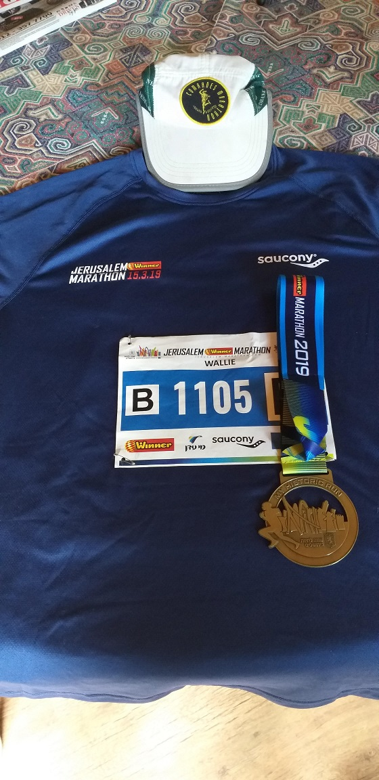
Om die Dam – Marix Venter
Vrydagmiddag het ons deurgery om die gazebo op te sit. Wilma du Plooy van Hartbeespoortdam Klub en ook sosiale lid van ons klub het ons slaapplek vir die aand aangebied. Het heerlik daar gekuier. Saterdagoggend 3 uur opgestaan, om 3:30 gery en toe is daar reeds rye motors. Soos altyd het die wedloop begin met die geroep van die arend en om 6 uur is dit die begin van ‘n lang dag. Ek en Hennie het saam gedraf. Dag om te onthou en waaroor ons nog lank gaan praat. Om die Dam bly ‘n moeilike Ultra. So, by 38km besluit ek maar om bietjie vooruit te gaan, nie dat dit gehelp het nie. Hennie vertel, toe die 7 ure cut off verby is stop daar ‘n bakkie by hom en sê klim op die bakkie, wedloop is verby. Hy klim toe maar op, die bakkie ry so 400m, die bestuurder bel toe vir Jan van Om die Dam, skreeu op hulle en sê klim af julle gaan nog medaljes kry, gaan maak klaar. Dink net vir die een oomblik dink jy dankie tog die wedloop is verby en die volgende oomblik moet jy weer die wedloop voltooi. Ek en Hennie het afsonderlik klaar gemaak maar almal klap hande en moedig ons vir oulaas aan, dit voel of ons wenners is. Harties klub gee vir ons almal ‘n medalje, ons het dit so waardeer en toe kry ek ‘n verrassing, Harties klub gee vir my ‘n bos blomme, ek was so moeg en kon skaars die blomme dra tot by die klubtent, hulle het my dag gemaak. Nog ‘n wedloop om te onthou. Dankie Jesus vir die voorreg om deel te kan neem aan wedlope. Aan Hom al die Eer!

Race Results
Sunnypark Right 2 Run (AGN) 10km race - 2019-03-21
Position | Initials | Surname | Sex | Age | Finish Time
147 | O | Pienaar | M | 48 | 00:53:28
233 | C | Burger | M | 54 | 00:58:41
420 | S | Brink | M |  | 01:06:05
494 | J | Barkhuizen | M | 49 | 01:07:59
688 | K | Nurden | M | 85 | 01:12:24
873 | D | Frost | M |  | 01:16:49
Sunnypark Right 2 Run (AGN) 21km race - 2019-03-21
Position | Initials | Surname | Sex | Age | Finish Time
126 | J | Pokwane | M | 47 | 01:37:06
241 | W | Reinecke | M | 44 | 01:47:28
414 | I | Van Der Merwe | M | 49 | 01:56:44
611 | M | Letsie | M | 51 | 02:05:53
741 | C | Greyling | F | 22 | 02:11:41
752 | L | Fourie | M | 74 | 02:12:24
822 | E | Van Zyl | F | 41 | 02:16:29
942 | E | Greyling | F | 49 | 02:21:35
943 | H | Greyling | M | 49 | 02:21:38
1153 | C | Mouton | F | 62 | 02:33:48
1192 | A | Te Reh | M | 69 | 02:37:26
1237 | G | Hughes | F | 71 | 02:42:18

League results

Training/Health snippets

Blisters
Surely every runner ever has had a blister? They can range from a barely noticeable bubble to a toe that looks like an angry cherry tomato! At their worst they can make running an uncomfortable nightmare or stop you altogether. So, what can you do about them?
Firstly, prevention is obviously better than cure, but that’s no help if you have one already! If you do there are a few key principles for treating them;
- Let it heal
- Reduce the friction
- Use appropriate wound/ blister care
- Deal with the cause
Let it heal
Blisters are usually caused by excessive friction when running, your first port of call may just be a couple of days rest. Skin heals quickly so if you can re-arrange your running schedule a little, you’ll probably find it will have healed enough by the time you run again. If you need to continue running, make sure you reduce friction as much as possible and dress the blister properly.
Reduce the friction
There are a few strategies for this;
Zinc Oxide tape is very useful – if the blister is still healing then place a plaster or gauze dressing over it then tape on top. If it has healed and is clean and dry you can usually tape over it. You can also tape on healthy skin to prevent blisters in vulnerable areas.
Compeed Blister Plasters are a good option – they expand in response to friction to protect the area.
Smothering the foot in Vaseline to reduce friction can also help. Cover the inside of the arch of the foot up to and including the base of the big toe. Also, worth doing the tips of the toes and in-between. Some people also put Vaseline on the outside of the sock and daub a little on the inside of the shoe where the friction is happening. Bodyglide is also a great option to use as a lubricant to reduce friction (thanks to Melissa for mentioning that in the comments section).
Select the right socks? I’ve put a question mark there because I haven’t found type of sock makes a great deal of difference to me. I’ve tried anything from £2 a pair from the bargain bin to £15 high tech ones that supposedly prevent blisters, wick sweat and occasionally complement you on your dress sense. The outcome always seems to be the same. Doubtless other runners may have socks they swear by (rather than swear at, in my case) so it’s worth shopping around and trying some out. Some favour using 2 pairs of very thin socks and this can be very effective.
Blister care
With any wound there is a risk of infection, with a blister this can delay healing, increase pain and could see you facing a couple of weeks off running. So, reducing infection risk is an important part of blister care. Common sense obviously applies – keep the feet and socks clean and your nails relatively short. You may want to use an antiseptic cream such as Sudacrem/ Savlon on the blister too.
Now the big question…to pop or not to pop?
The sensible answer is usually don’t pop it – A blister is a fluid filled sack that protects raw, healing skin. It contains the nutrients the area needs to heal and forms a barrier to infection. Sticking a needle in there introduces bacteria and increases infection risk. This is also the advice of NHS choices. If you can rest from running for a few days and just let it settle this is often the most simple and safest approach. You can also use a soft dressing for comfort, even if the blister hasn’t burst.
However, this is a site for runners, when have we ever been ‘sensible’?
It may be that the blister is so large that the pressure build up is painful and you feel you really need to pop it. Or, just as likely, you need to run for an event or training and it’s too painful. This is where there is an argument for ‘popping it’. When you run it’s quite likely it will pop anyway, so it may well be safer, and less painful to do this in a controlled, relatively sterile manner at home then you can then dress it afterwards. Or, you could go to your GP or Practice Nurse for them to aspirate and dress it. Again, this would be sensible and what I would recommend in an ideal world. I do however know runners, and there is little chance they’d see their GP about a blister! If you do choose to pop your blister at home, then wash the foot thoroughly first and use a sterile needle.
When dressing a burst blister don’t remove the surrounding skin (this process is called de-roofing) as it protects the healing skin underneath. Allow the fluid to drain and cover with a dry, sterile dressing. NHS choices recommend hydrocolloid dressings, such as duoderm. They have more info on treating blisters and applying dressings.
Watch out for signs of infection – these include swelling, redness surrounding the blister, yellow/green discharge or puss from the wound (not to be confused with normal transparent yellowish fluid you might expect from a blister) increase in pain and excessive heat from the area.
Deal with the cause
If you simply return to running in the same shoes after a blister has formed there’s every chance it could recur. Try to identify the cause and address it. In most cases it comes down to either your running shoes or the terrain you run on. Shoes that are too small, too big, too narrow or too wide can result in excessive friction. Also, insoles or defects within the shoe can rub and cause problems. Doing lots of hill work can also cause blisters, especially on the toes as they move forward in the shoe as you run downhill.
Tips from a podiatrist
During my marathon training I saw a podiatrist who gave me a couple of tips;
- Use the insole of the shoe to see how much room you have around your toes
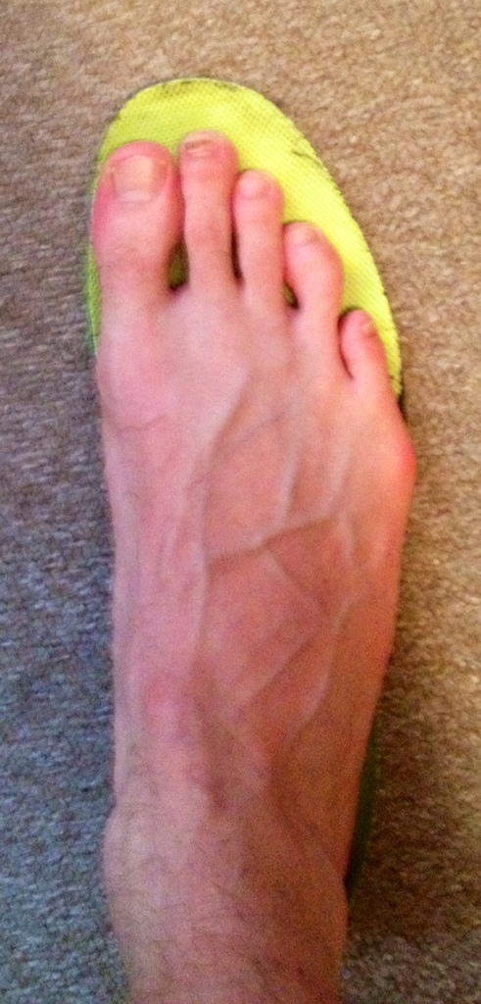
- See if you tend to ‘claw’ your toes during running. This means you tend to flex your toes into the sole of the shoe for extra stability, it causes greater pressure and friction at the end of the toes. To remedy this try and consciously relax the toes from this position, you may also need to work on your balance to improve your stability.
“Prevention: shoe choice and fit, merino socks, Vaseline, don’t forget some footbeds [insoles] are better than stock, and train on race terrain – poor prep/ not testing gear in both the conditions and terrain probably main error.”
“Blisters do nicely doing nothing! Doing things may help keeping going in an event or to return to training again comfortably ASAP. Once blistered my favourite is to pop/aspirate (using sterile needle and syringe) tape down with mefix* on dry clean skin and apply Vaseline over that.”
“Compeed is very impressive if used early on dry prepped skin. Mefix on top, can last 75 miles in the wet.”
*Mefix is a self addhesive fabric tape.

Your thought for the week
The one thing that you have that nobody else has is you. Your voice, your mind, your story, your vision. So, write and draw and build and play and dance and live as only you can!

Your smile for the week

Where are we?
A husband and wife were driving through Louisiana. As they approached Natchitoches, they started arguing about the pronunciation of the town. They argued back and forth, then they stopped for lunch. At the counter, the husband asked the blonde waitress, “Before we order, could you please settle an argument for us? Would you please pronounce where we are very slowly?” She leaned over the counter and said, “Burrr-gerrr Kiiing!”

==

A blonde walk into a library.
"PLEASE CAN I HAVE A CHEESEBURGER?!" he shouts at the top of his lungs.
"Sir, this is a library," the librarian says.
"Oh, sorry," he whispers. "Please can I have a cheeseburger?"

Something to ponder over / something spiritual

Teach Me to Forgive

One day a while back, a man, his heart heavy with grief, was walking in the woods. As he thought about his life this day, he knew many things were not right. He thought about those who had lied about him back when he had a job.
His thoughts turned to those who had stolen his things and cheated him. He remembered family that had passed on. His mind turned to the illness he had that no one could cure. His very soul was filled with anger, resentment and frustration.
Standing there this day, searching for answers he could not find, knowing all else had failed him, he knelt at the base of an old oak tree to seek the one he knew would always be there, and with tears in his eyes, he prayed
"Lord - You have done wonderful things for me in this life. You have told me to do many things for you, and I happily obeyed.
Today, you have told me to forgive. I am sad, Lord, because I cannot. I don't know how. It is not fair Lord. I didn't deserve these wrongs that were done against me and I shouldn't have to forgive. As perfect as your way is Lord, this one thing I cannot do, for I don't know how to forgive. My anger is so deep Lord, I fear I may not hear you, but I pray that you teach me to do this one thing I cannot do - Teach me To Forgive."
As he knelt there in the quiet shade of that old oak tree, he felt something fall onto his shoulder. He opened his eyes. Out of the corner of one eye, he saw something red on his shirt. He could not turn to see what it was because where the oak tree had been was a large square piece of wood in the ground. He raised his head and saw two feet held to the wood with a large spike through them. He raised his head more, and tears came to his eyes as he saw Jesus hanging on a cross. He saw spikes in His hands, a gash in His side, a torn and battered body, deep thorns sunk into His head.
Finally, he saw the suffering and pain on His precious face. As their eyes met, the man's tears turned to sobbing, and Jesus began to speak.
"Have you ever told a lie, He asked?" The man answered, "Yes, Lord."
"Have you ever been given too much change and kept it?" The man answered, "Yes, Lord." And the man sobbed more and more.
"Have you ever taken something from work that wasn't yours," Jesus asked? And the man answered, "Yes, Lord."
"Have you ever sworn, using my Father's name in vain?" The man, crying now, answered, "Yes, Lord."
As Jesus asked many more times, "Have you ever"? The man's crying became uncontrollable, for he could only answer, "Yes, Lord."
Then Jesus turned His head from one side to the other, and the man felt something fall on his other shoulder. He looked and saw that it was the blood of Jesus. When he looked back up, his eyes met those of Jesus, and there was a look of love the man had never seen or known before. Jesus said, "I didn't deserve this either, but I forgive you."
It may be hard to see how you're going to get through something. But, when
you look back in life, you realize how true this statement is...

"If God brings you to it... He will bring you through it."

Cancelled Races

Notice Board

Useful Links:
www.raceresults.co.za/flyers - for the latest race pamphlets
www.agn.co.za/#League for the latest league logs and the league points you earned

LEAGUE RACE
Saturday 30 March Kolonnade Road Race 32/15/5 km
Race Organisers: Overkruin Athletics Club
Venue: Kolonnade Shopping Centre, c/o Sefako Makgatho Drive & Dr van der Merwe Street, Montana

 | 32 km | 15 km | 5 km
Entry fee | R 110 | R 90 | R 40
Entry fee 60+ (Race day only & proof of age) | Free
Start Time | 06:00 |  | 06:15
Cut-off | 04:00 | 03:00

No Pets

No iPods or listening devices are allowed

Pre-entries at: Run-away Sport; Sweat Shop Irene; Tshwane Running Shop; Kolonnade Info Desk

www.entrytime.co.za

Saturday 6 April Ford 3-in-1 Road Race 21.1/10/5 km
Race Organisers: Ford Athletics Club
Venue: Ford Motor Company Sports Ground, c/o Simon Vermooten & Alwyn Road, Silverton

 | 21.1 km | 10 km | 5 km
Entry fee | R 100 | R 70 | R 50
Start Time | 06:30 |  | 06:45
Cut-off | 03:00

No Pets

No iPods or listening devices are allowed

Pre-entries at: Run-away Sport; Sweat Shop Irene; Tshwane Running Shop

www.entrytime.co.za

Sunday 7 April JointEze Irene Ultra 48/21.1/5 km
Race Organisers: Irene Athletics Club
Venue: ARC Irene Campus, Nelmapius Road, Irene
GPS: S25 53’31 E 28 11’28

 | 48 km | 21.1 km | 5 km
Entry fee | R 230 | R 110 | R 50
Entry fee 60 - 69 | R 150 | R 60 | R 50
Entry fee 70+ | Free
Start Time | 05:30 |  | 06:00
Cut-off | 06:00 | 03:30

Fun run is wheelchair friendly

48/21.1km athletes have an option to purchase t-shirt when entering

No Pets

No iPods or listening devices are allowed

Pre-entries at: ??

www.championchip.co.za

League Race
Saturday 13 April Frenus Zietsman Run/Walk against drugs 21.1/10/5 km
Race Organisers: Mamelodi Athletics Club
Venue: Pilditch Athletic Stadium, Maltzan Street, Pretoria West

 | 21.1 km | 10 km | 5 km
Entry fee | R 100 | R 80 | R 50
Start Time | 07:30
Cut-off | ??

The race is wheelchair friendly

No Pets

No iPods or listening devices are allowed

Pre-entries at: Run-away Sport; Sweat Shop Irene; Tshwane Running Shop; Cross Trainer Sunnypark; Sport Scene Sunnypark

www.entrytime.co.za

Saturday 20 April Castle Walk Easter Road Race 10/5 km
Race Organisers: Fusion Sports
Venue: Castle Walk Shopping Centre, c/o Nossob & Swakop Streets, Erasmuskloof

 | 10 km | 5 km
Entry fee | R 90 | R 50  Children under 12  R 30
Start Time | 07:00 | 07:15
Cut-off | ??

Pets allowed on the 5km only

Wheelchair athletes are allowed on the 5km only

No iPods or listening devices are allowed

Pre-entries at: Run-away Sport; Sweat Shop Irene, Dunkeld West & Fourways; Curves Castle Walk Shopping Centre

Monday 22 April Run-a-way Sport Family Day Run/Walk 22/11/6 km
Race Organisers: Run/Walk for Life Athletics Club
Venue: Lynnridge Mall, c/o Jacobson & Lynnwood Road, Lynnwood

 | 22 km | 11 km | 6 km
Entry fee | R 90 | R 70 | R 50
Start Time | 07:00
Cut-off | ??

Wheelchair athletes welcome

No Pets

No iPods or listening devices are allowed

Pre-entries at: Run-away Sport; Sweat Shop Irene

www.entrytime.co.za

2019 AGN LEAGUE FIXTURE LIST
EVENT | DISTANCE | DATE | LEAGUE
 |  |  | RR | RW
Kolonnade Road Race | 32/15 km | 30/03/19 | X | X
Run Against Drugs | 21.1/10 km | 13/04/19 | X | X
Skosana Development Run | 21.1/10 km | 25/05/19 | X | X
Race of Friendship | 21.1/10 km | 29/06/19 | X | X
Zwartkop Road Race | 21.1/10 km | 27/07/19 | X | X
Spirit of Flight | 10 km | 31/08/19 | X | X
Brooklyn Road Race | 21.1/10 km | 07/09/19 | X | X
Capital Classic | 21.1/10 km | 05/10/19 | X | X
Freedom of Expression | 21.1/10 km | 02/11/19 | X | X

Masters Athletics Fixture list

South Africa
29/30 March 2019 PE Westbourne Oval
29/30 March GNMA Pilditch
13 April 2019 WP Cape Town
13 April 2019 CGMA Herman Immelman
10 August 2019 Mpumalanga Secunda
? October 2019 Rassies Bronkhorstspruit
25/26 October 2019 SWD Oudtshoorn
8/9 November 2019 Free State Bloemfontein

South African Championships
2/3/4 May 2019 SWD Oudtshoorn
April/May 2020 Central Gauteng Herman Immelman

Africa Championships
2021 Nairobi, Kenya
2023 South Africa

International Championships
24-30 March 2019 WMA Indoor Torun, Poland
28/9-6/10 2019 30th Summer universiade Naples, Italy
20/7/2020 – 1/8/2020 World Masters athletics Champs Toronto, Canada

Time Trials:

Centurion - Wednesdays at 17:30
Lewende Woord Centurion
Contact Marinda 654 5800 (h) / 082 720 9017

Zita Park - Tuesdays at 17:30
Zita Street, Zita Park, Garsfontein
Contact Hennie Venter – 082 676 6792

Gazebo Enquiries

Hennie Venter – 082 676 6792

INTERCESSOR



Jaco Barkhuizen 083 519 1737

Agapé Executive 2018/2019

Name | Position | Telephone number | E-mail address
Hennie Venter | Chairperson | 082 676 6792 | henniev@seng.co.za  venterhennie08@gmail.com
Hennie Venter | Registrar & Club Captain | 082 676 6792 | henniev@seng.co.za  venterhennie08@gmail.com
Marieta Bortoli | Treasurer & Vice chairperson | 082 466 7031 | marietabortoli@gmail.com
Marieta Bortoli | Secretary & Editor | 082 466 7031 | marietabortoli@gmail.com
De Wet de Beer | Race organizer & PRO | 082 373 2987 | dewet@styletechnique.co.za
Jaco Barkhuizen | Intercessor | 083 519 1737 | jaco00028@gmail.com
Marix Venter | Clothing co-ordinator | 072 541 7268 | ventermarix9@gmail.com
Marix Venter | General activities | 072 541 7268 | ventermarix9@gmail.com
Gustav Brink | Statistician | 083 417 8431 | gustav.brink@gmail.com

Agapé Executive


Hennie Venter Marieta Bortoli De Wet de Beer


Jaco Barkhuizen Marix Venter Gustav Brink (Ex-officio)

